[E118] Pressure meter

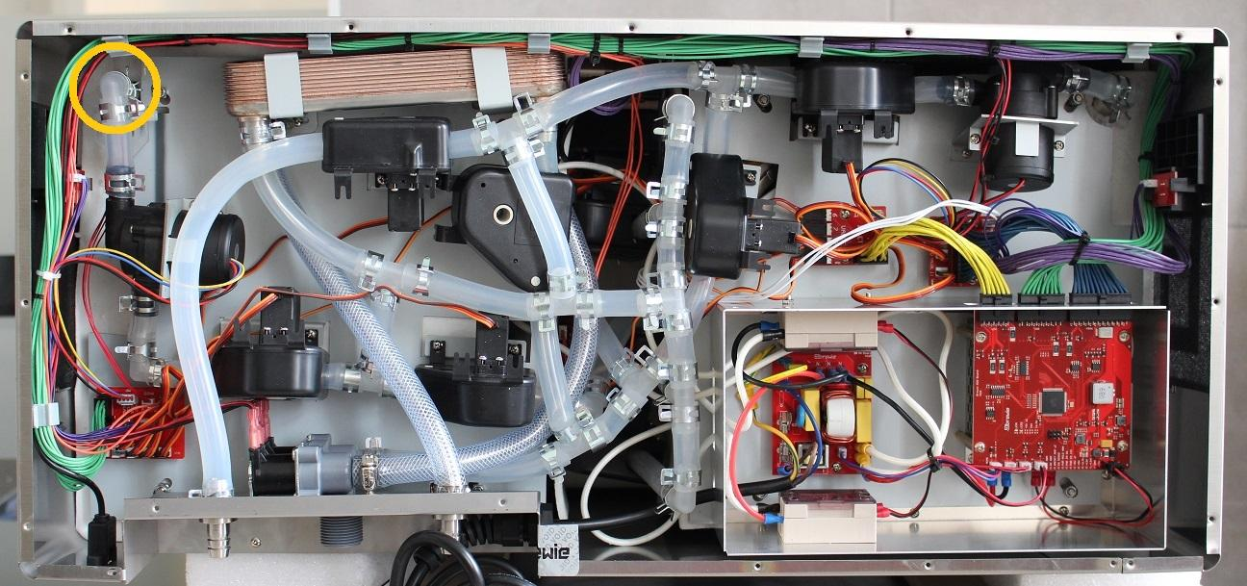

The pressure meter is mounted in a T junction right under the boil tank outlet. To remove the mounting pull off the pipe clamps under and over it and disconnect the cable.

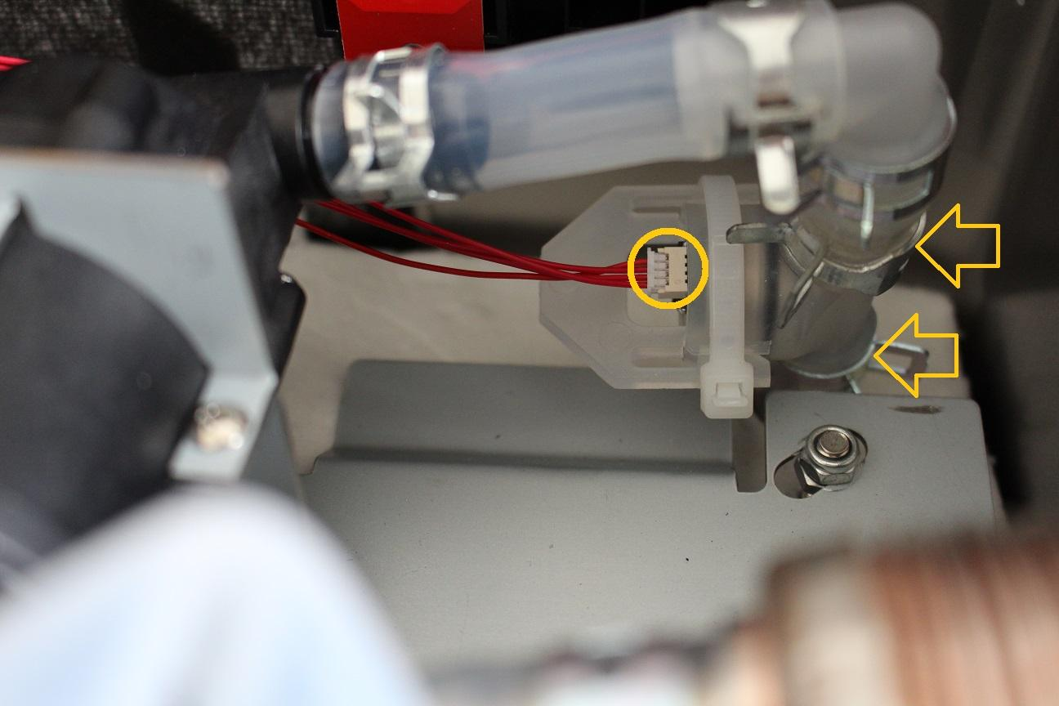

After pulling off the silicone tubes, the mounting can be removed from the machine.

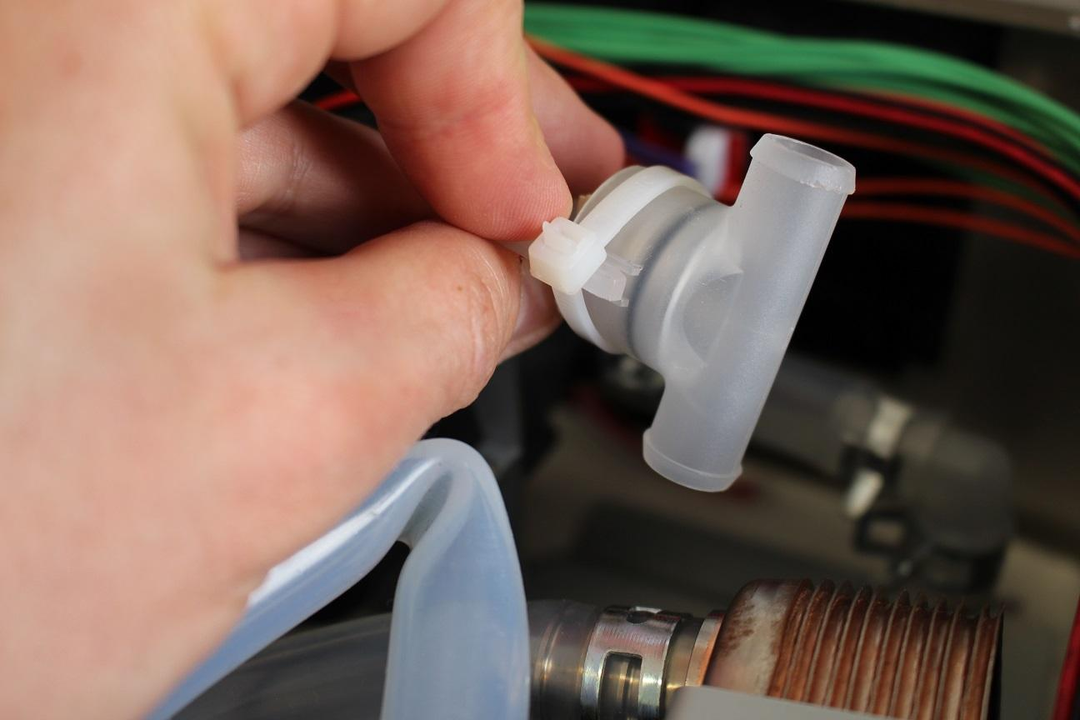

First cut the ziptie and remove the safety clamp. To remove the pressure meter itself, blow pressurized air with a compressor (maximum 1.5 bar) in the mounting while covering (even by hand) the other end of the pipe. The pressure will slowly push out the pressure meter from the mounting.

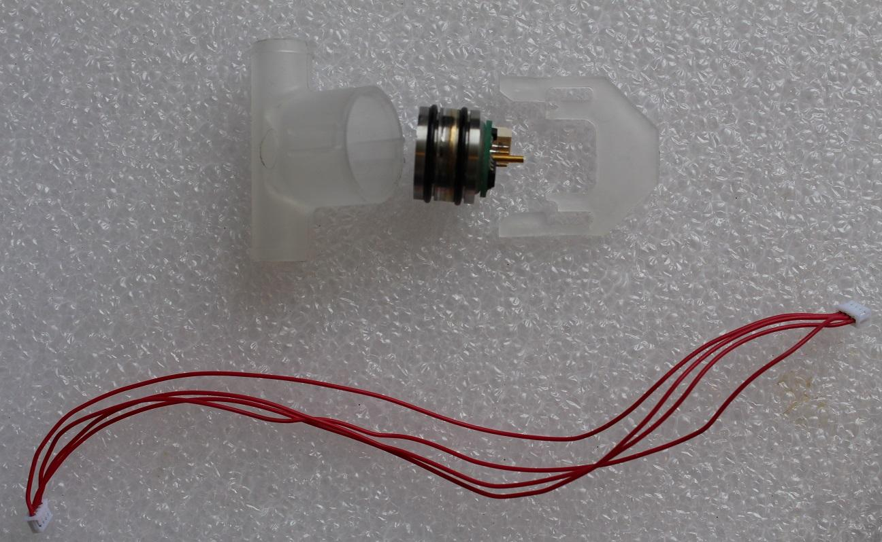

Reassemble consists of the same steps in reverse.

IMPORTANT: Don’t forget to replace the ziptie.